Press Release  For more information: Katrin Hoffmann  DTM Print GmbH  Phone: +49 611 927770  E-Mail: presse@dtm-print.eu  WWW: dtm-print.eu |  | 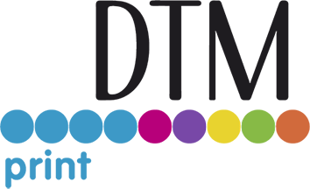

DTM Print Introduces Robert Boyce as New Sales Manager UK
This strategic appointment aims to further solidify DTM Print’s market position in the UK and drive growth through enhanced sales efforts and customer engagement.
Wiesbaden, Germany (6 May 2025) – DTM Print, international OEM and solution provider for specialty printing systems, is pleased to announce the appointment of Robert Boyce as its new Sales Manager for the UK at the company’s subsidiary DTM Print Ltd., effective 1 May 2025.
Robert Boyce brings with him over 14 years of extensive experience in the printing industry, with a strong background in sales and business development. His expertise will further strengthen DTM Print’s commitment to delivering innovative printing solutions and exceptional customer service across the UK market.
Boyce will work closely with Guy Boxall, Senior Sales Manager, who has been leading the UK office since June 2021. Together, they will focus on expanding DTM Print’s presence and supporting the growth of its diverse portfolio of digital printing technologies.
“I can’t wait to join DTM Print and to work alongside Guy and the rest of the team,” says Boyce. “I look forward to building on the company’s success and helping our UK customers achieve their business goals through cutting-edge printing technology and dedicated service.”
In his new role, Robert will be responsible supporting existing customers and exploring new business opportunities. His appointment underscores DTM Print’s commitment to strengthening its local sales teams and enhancing customer support.
Boxall adds: “We are excited to welcome Robert onboard. His experience and enthusiasm will be invaluable as we continue to expand our presence in the UK and deliver tailored solutions to our clients.”
To learn more about DTM Print visit dtm-print.eu. Follow DTM Print on Facebook at facebook.com/dtm.print.1986 and on LinkedIn at linkedin.com/company/dtm-print.
### Ends ###

