Press Release  For more information: Katrin Hoffmann  DTM Print GmbH  Phone: +49 611 927770  E-Mail: presse@dtm-print.eu  WWW: dtm-print.eu |  | 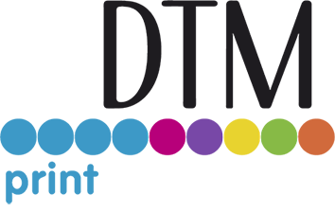

New AP-CODE Lot and Date Coding Module for Label Applicators
Prints lot codes, dates and texts directly onto glass, metals, plastics, laminated labels and more
Wiesbaden, Germany (20 April 2023) —The AP-CODE Lot and Date Coder is a great accessory for the label application process, adding the feature of printing dates, lot codes and text directly onto glass, metals, plastics and even laminated labels. As announced by DTM Print, international OEM and solution provider for specialty printing systems, this date coder, manufactured by Primera Technology, Inc., is compact, affordable and easy to use. It is designed to work seamlessly with the AP-Series Label Applicators, including new and existing installed units.
With no tools required, AP-CODE installs quickly to the AP360e and AP362e Label Applicators. It doesn’t need a separate power supply and includes a full-colour touchscreen to enter data and configure date and lot codes. The print fields are free-format and can include letters, numbers and many symbols. Formats can be stored for later use to speed up production.
As AP-CODE is attached to an AP-Series label applicator, you get one integrated machine that prints lot codes, dates and more directly onto round containers while at the same time labels are applied. Of course, AP-CODE can add this information without the need to simultaneously apply a label and can also print on pre-applied labels.
It uses a single black solvent-based ink cartridge that is long lasting, immediately dry, waterproof, scratch- and UV light resistant. Decap time, during which the cartridge can remain uncovered, is more than 24 hours, eliminating clogs and needing to cap print heads overnight.
“AP-CODE, in combination with the AP360e and AP362e Label Applicators, eliminates the need of applying extra labels or using hand-stamping devices to add lot codes, dates or texts to your container,” says Lea König, Product Manager for Labelling Solutions at DTM Print. “That’s a huge benefit for our customers as it significantly increases their production efficiency.”
The AP-CODE sells for € 1,149 (MSRP) and is available from DTM Print or through authorised DTM Print partners in Europe, Middle East and Africa.
Product information about AP-CODE and the AP-Series Label Applicators is available at dtm-print.eu. Follow DTM Print on Facebook at facebook.com/dtm.print.1986 and on Twitter at twitter.com/DTM_Print_.
### Ends ###

