News Release  For more information: Katrin Hoffmann  DTM Print GmbH  Phone: +49 (0) 611 92777-0  FAX: +49 (0) 611 92777-50  E-Mail: presse@dtm-print.eu  WWW: dtm-print.eu |  | 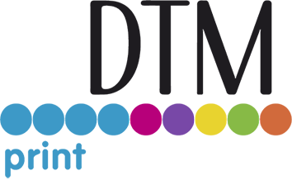

Eddie’s First Time Appearance at the Cake & Bake Show
Eddie Edible Ink Printer turns treats into highlights by printing directly onto baked goods and confectionery.
WIESBADEN, GERMANY (30 September 2021) – Eddie is the first-and-only EU/FDA approved edible ink printer that prints full-colour photos, logos, designs and text directly onto the surface of baked goods and confectionery. It saves bakeries a lot of time as they no longer have to print on wafer paper or fondant/icing sheets. DTM Print, international OEM and solution provider for specialty printing systems, will present Eddie for the first time at the Cake & Bake Show, the UK’s biggest baking event at ExCeL London, from 1st to 3rd of October 2021. DTM Print will await visitors at stand B50.
A highly professional look and great detail are realised, even on curved and uneven surfaces. Printed food items can be up to 89 mm (on automatic mode) or up to 120 mm (on manual mode) wide depending on the feeding mode and will be dry and ready for sale immediately after printing. Eddie prints up to 6 print objects per minute.
Due to direct printing, there is no strange film or aftertaste, which would decrease the quality of the food. The edible ink meets all EU and FDA standards for use as a food additive, while the ink cartridge itself meets cGMP standards and the entire manufacturing and cartridge filling processes are FDA-compliant and cGMP certified. In addition, the edible ink is Kosher and Halal certified and suitable for vegans.
Eddie turns treats into highlights and opens up new profits by offering branded and bespoke products. Eddie was designed for professional and semi-professional users, and keen hobbyists, who want to take their creativity to the next stage. Helping to increase production and profit margins, offering greater customisation and personalisation.
Product details and videos are available at dtm-print.eu. Follow DTM Print on Facebook at https://www.facebook.com/dtm.print.1986/ and on Twitter at https://twitter.com/DTM_Print_.

