News Release  For more information: Katrin Hoffmann  DTM Print GmbH  Phone: +49 (0) 611 92777-0  FAX: +49 (0) 611 92777-50  E-Mail: presse@dtm-print.eu  WWW: dtm-print.eu |  | 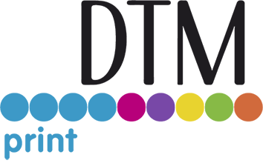

LX610e Pro and LX600e Now Mac Compatible
The printer driver, the label design and the die-cutting software for macOS are available for download.
WIESBADEN, GERMANY (24 February 2021) – DTM Print, international OEM and solution provider for specialty printing systems, today announced that the LX610e Pro and LX600e Color Label Printers are now compatible with Mac. LX610e Pro is a full-colour, desktop label printer/plotter that combines colour inkjet label printing with a built-in digital die-cutting mechanism. If no cut to shape labels are needed, the LX600e is the budget solution. It encompasses all the same quality features of the LX610e Pro including a maximum print width of 127 mm (5”) and a print speed of up to 114 mm (4.5”) per second.
The LX610e Pro comes with the easy-to-use software PTCreate™ Pro, which can now be used with Mac and Windows alike. PTCreate Pro allows the fast production of custom labels of virtually any size or shape all in one process. An auto-trace cut function in PTCreate Pro will automatically find the edges of the artwork and is especially useful for printing and cutting label outlines and designs regardless of the complexity, shape or size. Additional tools include layering, export of images and contour cutting around intricate artwork.
The new print driver for Mac, PTCreate Pro as well as the macOS label design and layout software Swift Publisher by Belightsoft can be downloaded for free from the DTM Print website. The licence key to activate PTCreate Pro is included with the LX610e Pro and can be used for Windows- or Mac-based computers. It is possible to switch between the operating systems or several computers at any time. To do this, the licence key only has to be deactivated on one computer before it is activated on the other.
Besides an intuitive software LX610e Pro and LX600e feature colour inkjet printing at up to 4800 dpi without horizontal banding, interchangeable dye or pigment inks and low maintenance by utilising an ultra-high capacity single CMY ink cartridge. In addition, both printers leave a green footprint as they are eco-friendly and sustainable with very low energy consumption, low weight by using less material, non-toxic ink supplies as well as 100% recyclable components.
Complete product details are available at dtm-print.eu. Follow DTM Print on Facebook at https://www.facebook.com/dtm.print.1986/ and on Twitter at https://twitter.com/DTM_Print_.

