News Release  For more information: Katrin Hoffmann  DTM Print GmbH  Phone: +49 (0) 611 92777-0  FAX: +49 (0) 611 92777-50  E-Mail: presse@dtm-print.eu  WWW: dtm-print.eu |  | 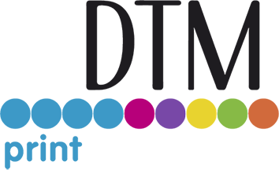

DTM Print offers a 3-years warranty
for its label printer and disc publisher division
WIESBADEN, GERMANY (24 September 2020) – DTM Print, international OEM and solution provider for specialty printing systems, now offers its customers a warranty period of up to 36 months. As before, all customers will automatically receive a 12-months warranty with their purchase. However, for purchases within the EU (including EFTA countries) they have the option of a free extension to a total of three years.
Warranty duration and warranty processing are very important for distributors, resellers and clients. They want to be sure that in the event of a breakdown, faulty devices can be replaced or repaired quickly and easily.
Optimally controlled processes and high quality management at DTM Print ensure effective handling of warranty claims. “Even with very high-quality components, warranty claims cannot be completely excluded. Therefore we decided to offer our partners and customers even more security,” emphasises Andreas Hoffmann, Managing Director of DTM Print. “Our promise is a voluntary warranty extension which must be clearly distinguished from the legal guarantee period. This is often confused in everyday language,” he adds.
The warranty applies for almost all devices of the label printer and disc publisher division if they are registered on the company website within the first 6 months after purchase. A full list of all included products and the detailed warranty conditions can be found at register.dtm-print.eu.
“The 3-years warranty not only represents a true benefit for users, but also gives DTM Print, its distributors and resellers the chance to build up long-term relationships with their customers,” summarises Andreas Hoffmann “Thereby our DTM Print partners have the opportunity to stand out from the crowd. They can make their customers a very attractive offer and the customer himself saves money by simply registering on the website. A real win-win situation.”
For more information visit dtm-print.eu.

